# **Static Website hosting with s3 bucket**

1. Create S3 bucket
2. Uncheck (Block all public access while creating a bucket)
3. Check on I acknowledge to confirm public access settings.
4. Create Bucket 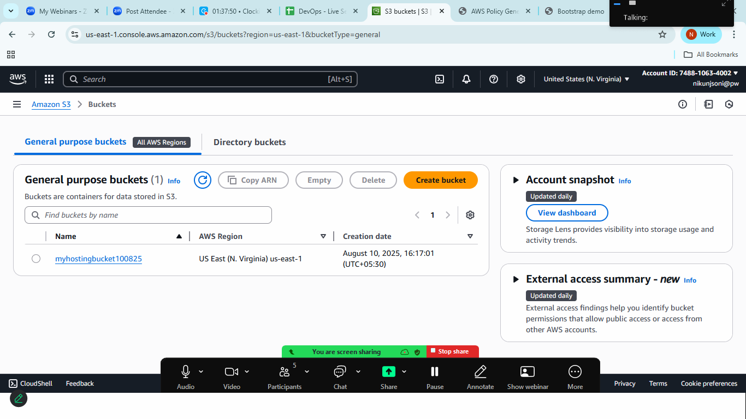
5. Now goto your local machine and create two files
   1. Index.html
   2. error.html

index.html

<!doctype html>

<html lang="en">

  <head>

    <meta charset="utf-8">

    <meta name="viewport" content="width=device-width, initial-scale=1">

    <title>Bootstrap demo</title>

    <link href="https://cdn.jsdelivr.net/npm/bootstrap@5.3.7/dist/css/bootstrap.min.css" rel="stylesheet" integrity="sha384-LN+7fdVzj6u52u30Kp6M/trliBMCMKTyK833zpbD+pXdCLuTusPj697FH4R/5mcr" crossorigin="anonymous">

  </head>

  <body>

    <div class="container bg-primary" id="home">

        <h1>This is Home Section</h1>

        <h2>This is Home Section</h2>

        <p>Scroll Bottom to check the next</p>

    </div>

    <div class="container bg-success" id="about">

        <h1>This is About Section Page</h1>

        <h2>This is About Section</h2>

        <p>Scroll Bottom to check the next</p>

    </div>

     <div class="container bg-info" id="about">

        <h1>This is Info Section Page</h1>

        <h2>This is Info Section</h2>

        <p>Scroll Bottom to check the next</p>

    </div>

    <script src="https://cdn.jsdelivr.net/npm/bootstrap@5.3.7/dist/js/bootstrap.bundle.min.js" integrity="sha384-ndDqU0Gzau9qJ1lfW4pNLlhNTkCfHzAVBReH9diLvGRem5+R9g2FzA8ZGN954O5Q" crossorigin="anonymous"></script>

  </body>

</html>

error.html

<!doctype html>

<html lang="en">

  <head>

    <meta charset="utf-8">

    <meta name="viewport" content="width=device-width, initial-scale=1">

    <title>Bootstrap demo</title>

    <link href="https://cdn.jsdelivr.net/npm/bootstrap@5.3.7/dist/css/bootstrap.min.css" rel="stylesheet" integrity="sha384-LN+7fdVzj6u52u30Kp6M/trliBMCMKTyK833zpbD+pXdCLuTusPj697FH4R/5mcr" crossorigin="anonymous">

  </head>

  <body>

    <div class="container bg-info" id="erro">

        <h1>There is an Error</h1>

    </div>

    <script src="https://cdn.jsdelivr.net/npm/bootstrap@5.3.7/dist/js/bootstrap.bundle.min.js" integrity="sha384-ndDqU0Gzau9qJ1lfW4pNLlhNTkCfHzAVBReH9diLvGRem5+R9g2FzA8ZGN954O5Q" crossorigin="anonymous"></script>

  </body>

</html>

1. now go back to aws s3 bucket and upload this two file on your bucket

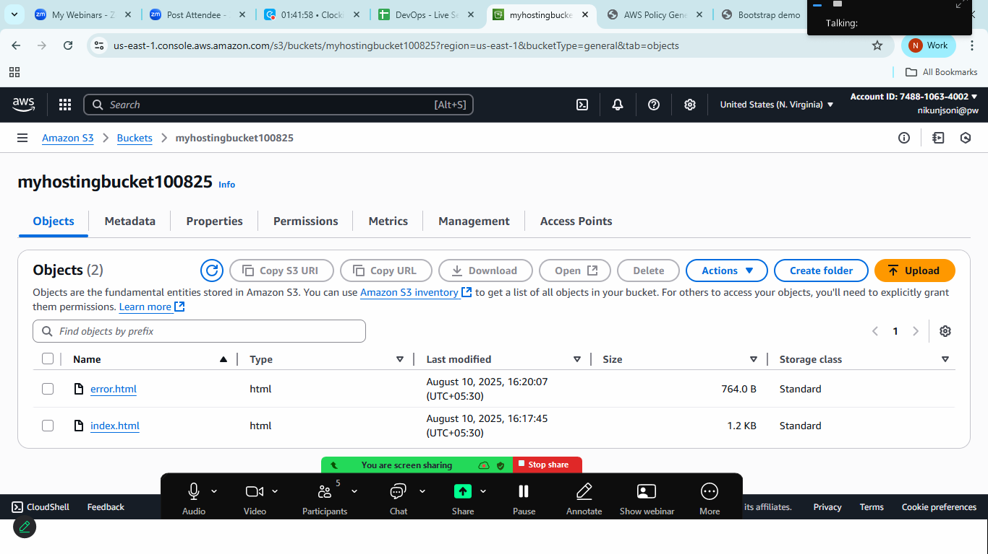

1. Now click on properties tab

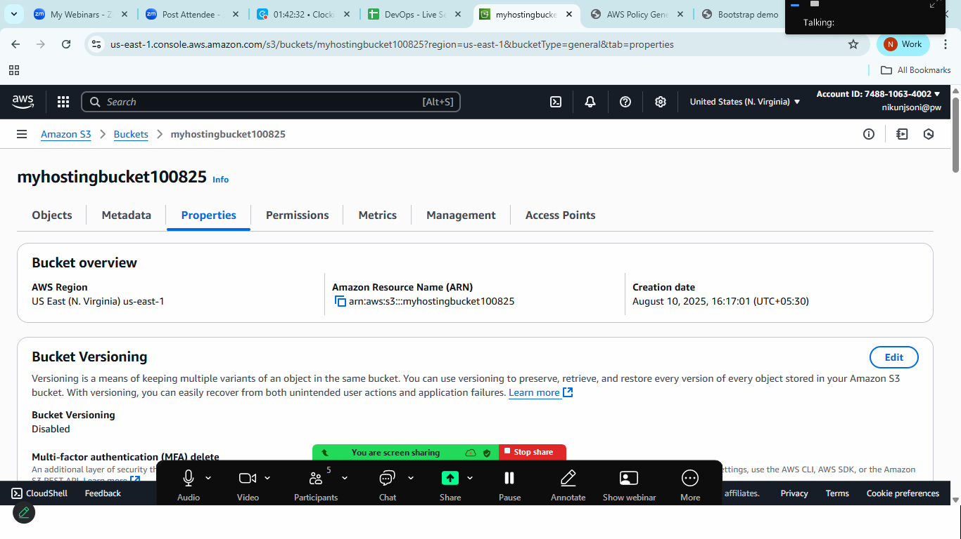

1. Scroll down to the bottom at Static website hosting

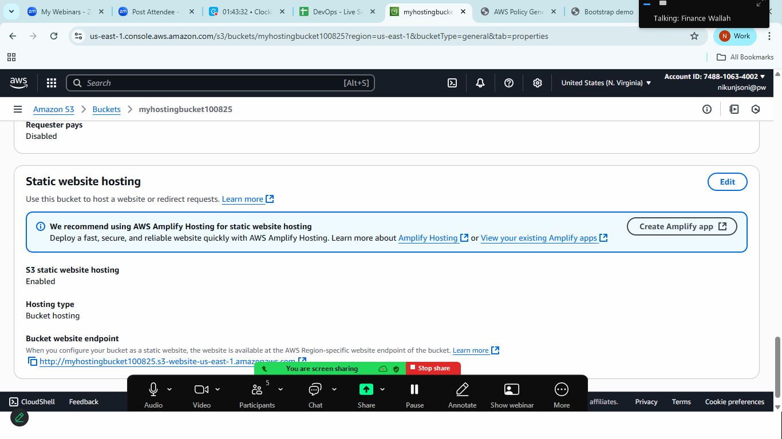

1. Click on Edit:
   1. Select enable
   2. Hosting type: Host a static website.
   3. Index document: index.html
   4. Error document: error.html
   5. Save the changes

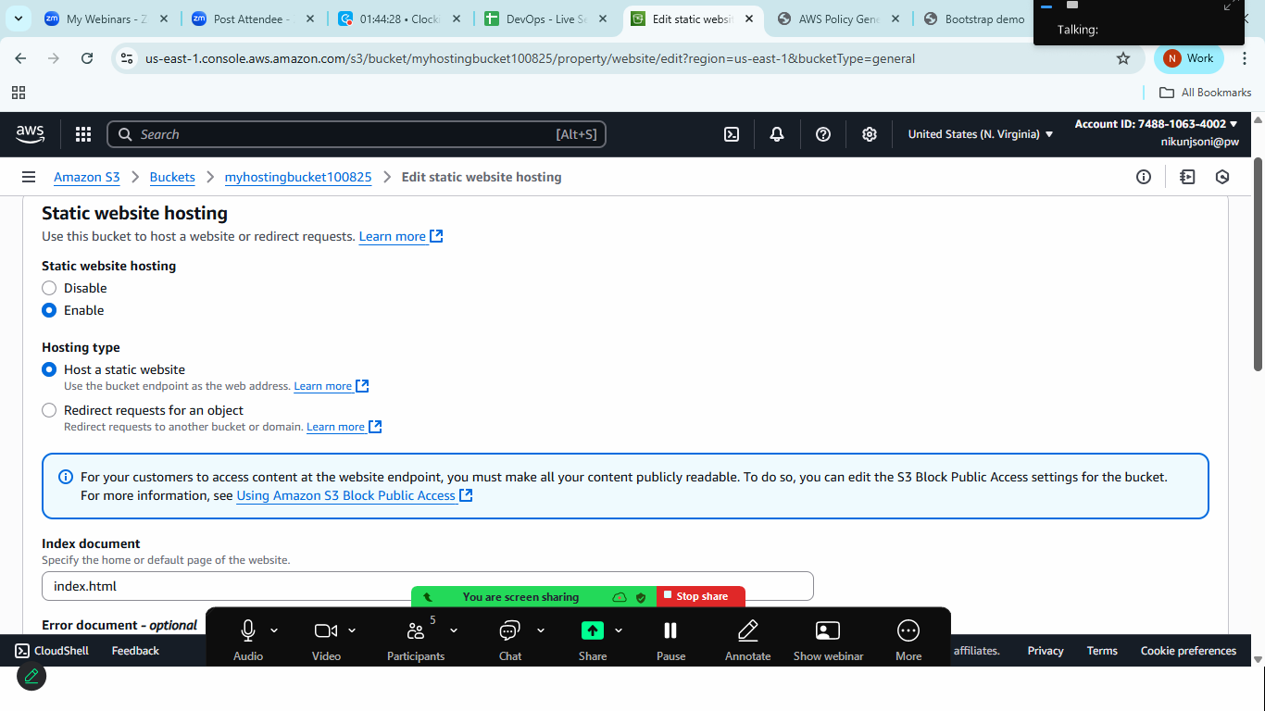

1. Make file public
   1. Goto> permission tab> bucket policy
   2. Either create policy using policy generator> choose s3 bucket> principle *> get object > copy paste arn>add statement> create policy and copy

Or

* 1. Add this policy

{

"Version": "2012-10-17",

"Statement": [

{

"Sid": "Statement1",

"Effect": "Allow",

"Principal": "*",

"Action": "s3:GetObject",

"Resource": "arn:aws:s3:::myhostingbucket100825/*"

}

]

}

1. Goto> bucket>properties> static website histing> copy the url

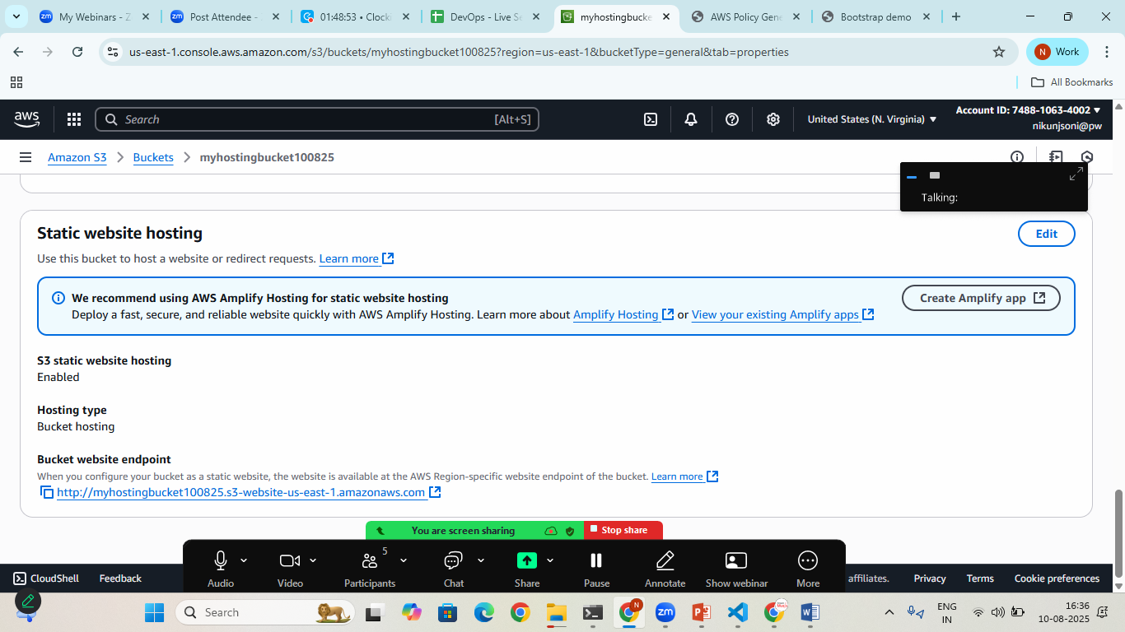

1. Output:

